Boy, 12, who sleeps for months at a time celebrates first Christmas awake in 4 year
Nicole Morley for Metro.co.uk - Thursday 29 Dec 2016

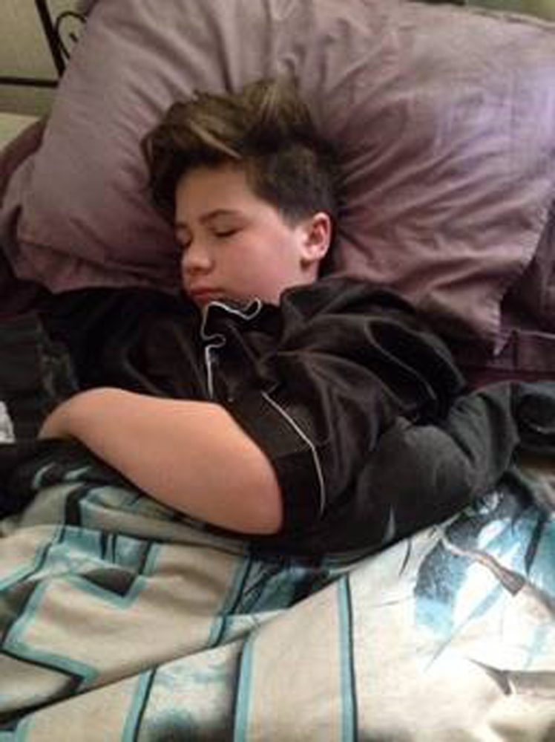
Connor’s condition causes him to sleep for months at a time (Picture: PA)
A 12-year-old boy who sleeps for three and a half months at a time has celebrated his first Christmas awake in four years.
Connor Prince, from Toton, Nottinghamshire, has rare sleep disorder Kleine Levin Syndrome, which has caused him to sleep through the past four Christmases.
His mum Dana, 44, said: ‘The last three years have put such a strain on the family, as we haven’t been able to plan any holidays.
‘I’ve had to give up work to look after Connor. He is sleeping through months of his life and special occasions, like Christmas. It’s heart-breaking to watch.’
She said the family were ‘over the moon’ when he was awake on December 25 long enough to play chess on his specially designed Harry Potter board.’
Connor was often sickly as a child and in the first few years of his life, he contracted measles, mumps and tonsillitis.
At the age of nine, Connor slept for a week and Dana and his dad, Andy Gough, 36, a manager at a local engineering firm, could not wake him up.
The family thought it was just because of the infection, but in November 2012, Connor fell asleep and didn’t wake up until January the following year.
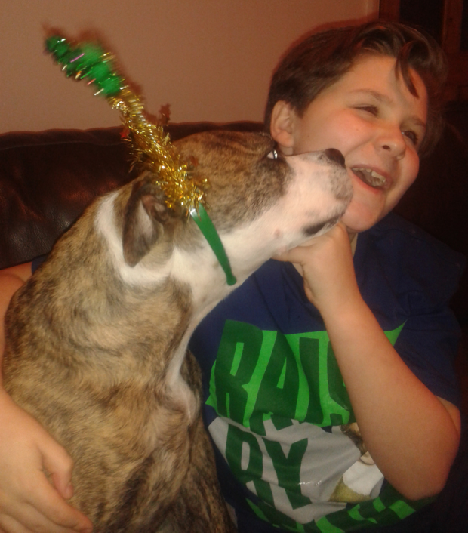
Connor just enjoyed his first Christmas awake for four years (Picture: PA)
During his periods of prolonged sleep, Connor stays awake only for a few minutes, to go to the bathroom or drink a nourishment shake, but he was very incoherent and confused.
From then on, every few weeks, he fell asleep for a couple of days or more and Dana took voluntary redundancy as a lecturer in September 2013 to look after him.
Her GP advised her that Connor had chronic fatigue syndrome and needed to be forced awake, but she suspected that there was more to her son’s problems.
Dana noticed a pattern in Connor’s habits, in the days before his ‘sleeping episodes’, his appetite would increase tenfold and he’d complain of aching limbs.
She came across the sleep disorder KLS on the internet after she started researching his symptoms.
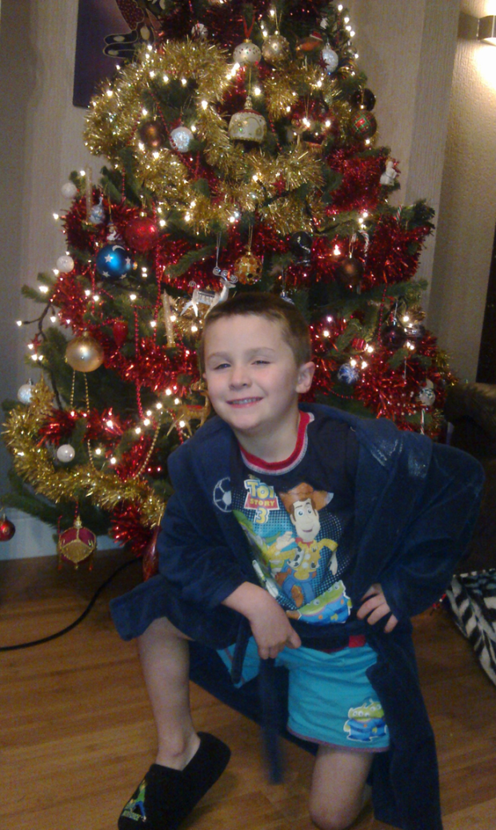
Connor suffers with KLS (Picture: PA)

KLS
Kleine Levin Syndrome is an extremely rare sleep disorder.
The rare neurological disorder affects just 1,000 people worldwide and has no cure.
After the revelation, Dana went to see her son’s GP again.
‘I asked his doctor to send Connor’s notes to the sleep clinic at Nottingham City Hospital and he was diagnosed straight away,’ she said.
‘It felt fantastic to get a diagnosis. But it’s a bitter pill to swallow, because you don’t want your child to miss large portions of his life and we know how hard it’s going to be for him.
Dana added: ‘What upsets Connor is the bits that he misses, he feels so isolated and alone. He’s losing so much for his life, it’s devastating.
‘I desperately hope he’ll grow out of KLS. I’ve heard of people who still have it in their twenties and thirties and have never had a normal life.
The family say they plan to take everyday as it comes.

